***Fitness Business Idea Presentation***

**Introduction & Business Idea**

Manhattan is the most densely populated of the five boroughs of New York City. Manhattan serves as the city's economic and administrative center, cultural identifier, and historical birthplace. The borough consists mostly of Manhattan Island, bounded by the Hudson, East, and Harlem rivers; as well as several small adjacent islands. Manhattan additionally contains Marble Hill, a small neighborhood now on the U.S. mainland, that was connected using landfill to the Bronx and separated from the rest of Manhattan by the Harlem River. Manhattan Island is divided into three informally bounded components, each aligned with the borough's long axis: Lower, Midtown, and Upper Manhattan.

I have been living in Manhattan for a few years. I love fitness and personal training and am currently working at a gym, but I have a business idea I want to explore. Given how densely populated Manhattan is and how busy many of the city's inhabitants are I stronly believe there is a need or desire for many people to be able to enjoy exercise outside, but in a more serene and natural environment. I believe people would benefit more and find exercise more enjoyful if they could do so away from roads and traffic, and even gyms, and a little closer to nature.

That's why I'm looking to start group personal training sessions in a Manhattan neighborood that has many parks, but also many gyms. Many parks for two reasons, one because it gives me a lot options for locations to hold the sessions, and two because it indicates that the people in the area enjoy the parks because they chose to live in an area that has many parks. Also ideally the neighborhood will have a lot of gyms because it shows there's high interest in the locals for excerise.

So what I'm hoping to find is at least 1 neighborhood with park's being the most common venue out of all list venues in the data set I will use. Ideally gyms will be the 2nd most common but 3rd or 4th will be fine too.

**Data**

First I will acquire the Manhattan boroughs and neighborhoods location data from geo.nyu.edu and put it into a pandas dataframe for examination and analysis, then visualize it using folium.

Then utilizing the Foursquare API i'll explore the neighborhoods and segment them. A new dataframe will be created to analyze the neighborhood data. I will run k-means to cluster the neighborhood into 5 clusters.

Using this data I will be able to know what the most suitable neighborhood is to pursue my business idea.

**Visualization**

Here is a look at all the neighborhoods, and therefore, potential candidates for my personal training business.

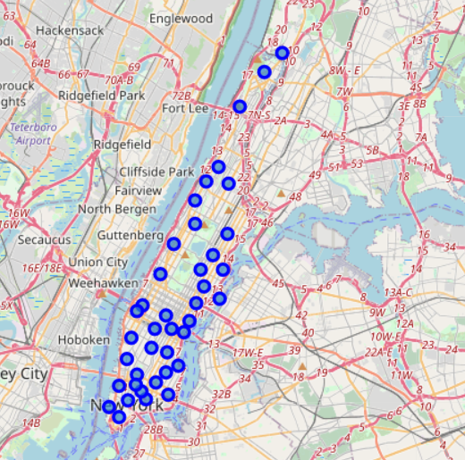

**Analysis**

After my analysis of the neighborhoods and their venues my result came to look like this:

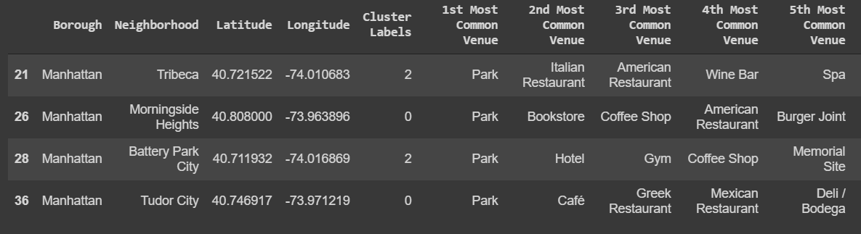

**Results**

There are 4 potential candidate neighborhoods for my personal trainer business which is good news. We can also see that Battery Park City is the most ideal location because it has Gym as the 3rd Most Common Venue.

**Discussion**

Battery Park City will be my prime candidate, but as I explore this idea more and do more deeper analysis maybe the other 3 might turn out to be more suitable.

**Conclusion**

My goal of finding the best neighborhood that matches my criteria as been achieved. Now it's time to check out these parks and move onwards with my plan!